Welcome 2020
San Marcos High School Seniors!

Dear Parents & Class of 2020,

P.S.S. Imaging is excited to offer senior sessions for the 2019/2020 school year at our Oceanside Studio located at 3365 Mission Avenue, Suite E., Oceanside, California 92058. Our studio will open for senior session at the end of July 2019, exact dates to be determined. PSS IMAGING will be on your campus to photograph seniors August 8th thru August 13th. In May 2019 you will receive a flier through the mail with information regarding booking a senior session.

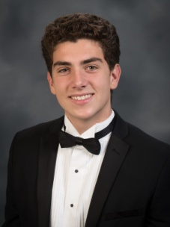

2020 Senior Yearbook Image Requirements:
San Marcos High School requires yearbook images to reflect students in Tux for the boys and Drape for the girls (provided by P.S.S. Imaging for imaging purposes only) on the grey yearbook background.

For additional information regarding senior portraits please visit the “Seniors” tab located at pssimaging.net. If you have any other questions or concerns you can contact us by e-mail at pssimaging@msn.com or by phone at (714) 630-7785. Our current office hours are Monday-Friday 10:00am-4:00pm.
We look forward to providing you with outstanding portraits!
PSS Imaging
1630 S Sunkist St, Suite S Anaheim, CA 92806
Studio: 714.630.7785

