#### San Marcos

#### Knights Athletics

#### 

#### 2021-2022

**Spectator Expectations**

At San Marcos High School we expect the following:

* Know and demonstrate good sportsmanship.
* Be positive – Cheer for the Knights instead against the other team.
* Refrain from booing and name calling.
* Respect the official’s judgment and interpretation of the rules.
* Exhibit respect for visiting and home coaches.
* Use no artificial noise makers.
* Let the players play, the coaches coach, and the officials officiate.

**Mission Statement**

The San Marcos High School Athletic program’s mission is to provide a rigorous athletic program which complements and supports a challenging and rigorous academic program. The San Marcos High School athletic program is comprised of student-athletes, coaches, administrators, staff and volunteers striving for excellence in sportsmanship, leadership, and success. We are united through our commitment to develop skilled student-athletes and teams with the emphasis always being on the student. We promote honor, dedication, and respect for ourselves, teammates, and opponents.

|  |
| --- |
|  |
|  |

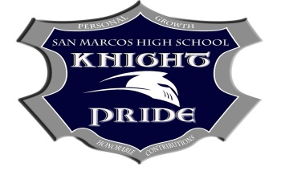

Pursuing Victory with Honor

*Code of Conduct for Parents/Guardians*

*Athletic competition of interscholastic age children should be fun and should also be a significant part of a sound educational program. Everyone involved in sports programs has a duty to assure that their programs impart important life skills and promote the development of good character. Essential elements of character building are embodied in the concept of sportsmanship and six core ethical values: trustworthiness, respect, responsibility, fairness, caring, and good citizenship (the “Six Pillars of Character” The highest potential of sports is achieved when all involved consciously Teach, Enforce, Advocate and Model (T.E.A.M.) these values and are committed to the ideal of pursuing victory with honor. Parents/guardians of student athletes can and should play an important role and their good-faith efforts to honor the words and spirit of this Code can dramatically improve the quality of a child’s sports experience.*

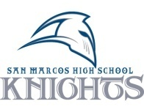

***Empowering personal growth and honorable contributions of all Knights*.**

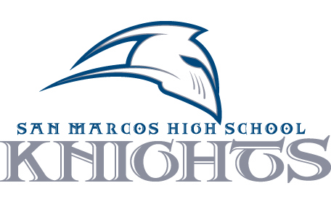

**San Marcos High School**

1615 San Marcos Blvd

San Marcos, CA 92078

760-290-2200

**ELIGIBILTY DATES**

**1st Semester Eligibility Dates**

1st Progress Report 9/24 Monday, 10/4

2nd Progress Report 11/5 Monday, 11/15

3rd Progress Report 12/16 Monday, 12/27

**2nd Semester Eligibility Dates**

1st Progress Report 2/25 Monday, 2/28

2nd Progress Report 4/22 Monday, 5/2

3rd Progress Report 6/9 Monday, 6/9

**Administration**

Principal………………….Adam Dawson

Asst. Principal/Athletics….John Livingston

Athletic Director…………Jeff Meyer

[jeffrey.meyer@smusd.org](mailto:Jeffrey.meyer@smusd.org) (760) 290-2318

ASB Advisor…………......Bonnie Bagheri

**Interscholastic Eligibility**

All students must meet the following requirements for eligibility to participate:

1. Insurance – All students participating on athletic teams must carry adequate insurance coverage.
2. All students must be residentially eligible. For more information about transfers; contact the Athletic Director’s office
3. All students must pass 20 credits, and maintain an Unweighted 2.0 GPA for all courses in which enrolled during the preceding grading period.
4. Summer School credits will count for deficiencies of the previous semester.

# Sports and Coaches

**Fall Sports Coach Email__________**

Football D. Stank derek.stank@smusd.org Men’s Cross Country K.Chindlund kevin.chindlund@smusd.org

Women’s Cross Country A. Cole andrew.cole@smusd.org

Men’s Water Polo T. Smith troy.smith8076@gmail.com

Women’s Tennis A. Kelts amy.kelts@smusd.org

Women’s Volleyball S. Clouet sherryclouet@sbcglobal.net

Women’s Golf R. Gordon robert.gordon@smusd.org

Women’s Field Hockey H. Harris Fhockey132002@yahoo.com

**Winter Sports Coach Email__________**

Men’s Basketball D. Carey dante.carey@smudsd.org

Women’s basketball R. DiCarlo roger.dicarlo@smusd.org

Men’s Soccer M. Hidalgo matt.hidalgo@smusd.org

Women’s Soccer D.McKell dmckell7@gmail.com

Women’s Water Polo D.Nelson derekmackenzienelson@gmail.com

Wrestling R. Williams ryan.williams@smusd.org

**Spring Sports Coaches Email__________**

Baseball J. Dufek jeff.dufek@smusd.org

Softball J.Terwilliger Julie.terwilliger@smusd.org Men’s Golf S. Norman scott.norman@smusd.org

Men’s Swimming M. Kleinert mfkleinert@gmail.com

Women’s Swimming M. Kleinert mfkleinert@gmail.com

Men’s Tennis A. Kelts amy.kelts@smusd.org

Men’s Track and Field K. Chindlund kevin.chindlund@smusd.org

Women’s Track and Field K. Smith [keenan.smith@smusd.org](mailto:keenan.smith@smusd.org)

Men’s Volleyball S. Clouet sherryclouet@sbcglobal.net

Men’s Lacrosse M. Mathai mathai.mike@gmail.com

Women’s Lacrosse R. Kingsbury coachrkingsbury@gmail.com

**Trainer Email_________**

Paul Savage paul.savage@smusd.org

**Alma Mater**

Hail to San Marcos, silver and blue,

Knights we will always be

Loyal and true to you.

Hail Alma Mater,

our hearts and minds we offer thee.

May your guiding spirit be with us in every word and deed.

Truth and honor, our motto this will ever be.

Blue and silver, colors symbolic of our creed.

All hail, Alma Mater, this hymn we sing to thee

All hail to San Marcos High School, hail to thee

**Clearance Procedures**

1. Pick up clearance packet from the student union, or front office.
2. Get a physical.
3. Fill out all forms and record insurance information on clearance packet.
4. Make sure to sign all portions of the Clearance Packet.
5. Turn the clearance packet in to the front office or Athletic Director.

**Protocol for Concerns/Questions**

1. Contact the coach in charge of your student’s team.
2. Contact the Head Coach of the program.
3. Contact the Athletic Director.
4. Contact the Assistant Principal in charge of Athletics.
5. Contact the Principal.

**Important Dates**

Starting Dates

Fall Sports: August 2, 2021

Winter Sports: November 6, 2021

Spring Sports: February 5, 2022